Practical - 6

**AIM : Deployment of ML project using Flask.**

**Task 1:** Ensure that the required libraries are installed

pip install Flask

pip install gunicorn

**Task 2:** Create the docker file using the steps described in theory material.

1. Create a Dockerfile :

FROM python:3.8-slim

WORKDIR /app

COPY . /app

RUN pip install --no-cache-dir -r requirements.txt

EXPOSE 80

ENV NAME World CMD ["gunicorn", "--bind", "0.0.0.0:80", "app:app"]

1. Create a requirement.txt file :

scikit-learn==0.24.2

pandas==1.3.3

numpy==1.21.2

gunicorn==20.1.0

Flask==2.0.2

Werkzeug==2.0.2

1. Create a Docker Image :

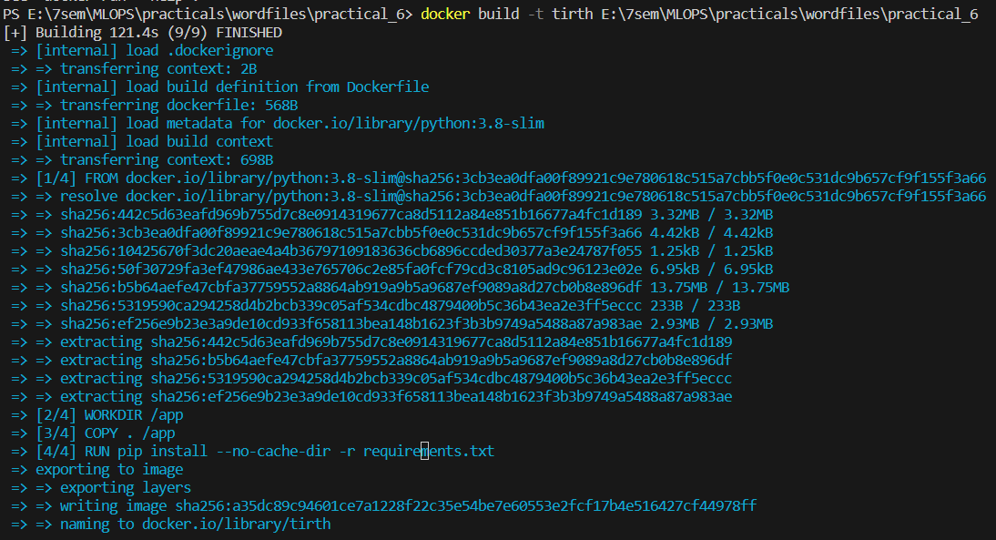

• Check the image is created or not :

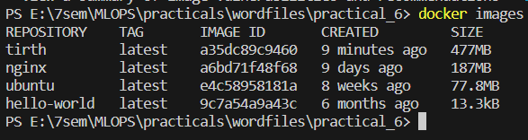

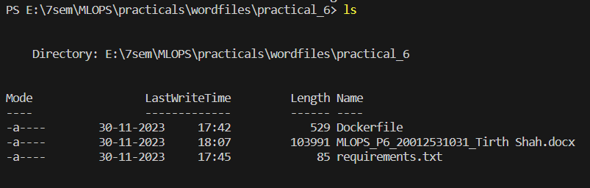

• Locate the file app.py and start build of a project

